**Step 1: Set Up Node.js Project**

Create a new directory & navigate into it:

**mkdir student-info-api**

**cd student-info-api**

**Step 2: Javascript code**

const http = require('http');

const url = require('url');

// student data

const students = {

'11111': { id: '11111', name: 'Bruce Lee', score: 84 },

'22222': { id: '22222', name: 'Jackie Chen', score: 93 },

'33333': { id: '33333', name: 'Jet Li', score: 88 },

};

// Create server

const server = http.createServer((req, res) => {

// Parse the URL

const parsedUrl = url.parse(req.url, true);

// Checking path matches the API endpoint

if (parsedUrl.pathname === '/api/score') {

const studentId = parsedUrl.query.student_id || parsedUrl.query.studnt_id; // Allow both query params

if (students[studentId]) {

res.writeHead(200, { 'Content-Type': 'application/json' });

res.end(JSON.stringify(students[studentId]));

} else {

res.writeHead(404, { 'Content-Type': 'application/json' });

res.end(JSON.stringify({ message: 'Student not found' }));

}

} else {

// Handle 404 for other routes

res.writeHead(404, { 'Content-Type': 'application/json' });

res.end(JSON.stringify({ message: 'Not Found' }));

}

});

// Run the server

const port = 8000;

server.listen(port, () => {

console.log(`Server running at http://localhost:${port}`);

});

**Step 3: Run the Server**

In your terminal, run the following command: **node studentinfo.js**

You should see the message:

Server running at <http://localhost:8000>



**Step 4: Test the Server in browser**

* For Bruce Lee:

<http://localhost:8000/api/score?student_id=11111>

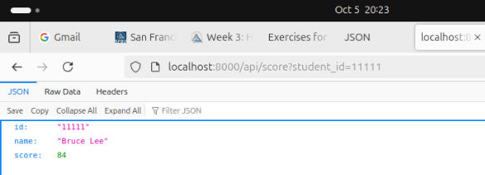

* For Jackie Chen:

http://localhost:8000/api/score?studnt_id=22222

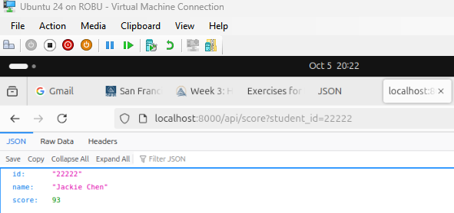

If you try an ID that does not exist, you will receive a 404 error with the message:

